Title XXXX

Name

Personal
Picture
Professor of XXX
University of XXX, City, Zipcode, China
Email: XXXX@XXX.com/edu

Abstract
XXXXXXXXXXXXXXXXXXX.

Brief Biography
Prof. XXXX

Develop Zymomonas mobilis as a chassis for lignocellulosic bioproducts
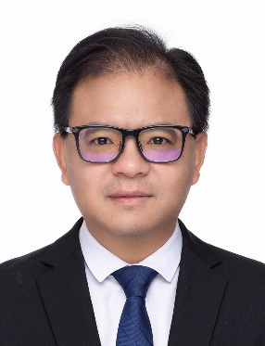
Shihui YANG
Professor of Microbiology
State Key Laboratory of Biocatalysis and Enzyme Engineering,
School of Life Sciences, Hubei University,
368 Youyi Avenue, Wuhan, Hubei, China 430062
Email: Shihui.YANG@hubu.edu.cn

Abstract
A key barrier for economic production of desirable lignocellulosic bioproducts is the development and deployment of robust microbial biocatalysts with high productivities and yields. Zymomonas mobilis is a natural ethanologen with many unique physiology characteristics, which makes it an ideal industrial microbial biocatalyst. I will briefly discuss our efforts to understand the hydrolysate inhibitor tolerance mechanisms using classical genetics and systems biology approaches, and insights we have obtained from these studies including the relationship between robustness and productivity. I will also present our work to develop Z. mobilis for other bioproducts using lignocellulosic biomass such as 2,3-butanediol and isobutanol, and our current effort to develop Z. mobilis as a chassis for synthetic biology practice including systematical identification and characterization of biological parts such as promoters and 5’ UTR, as well as regulatory network by characterizing the global regulators and their interactions. In addition, efforts to develop tools for genome minimization of Z. mobilis including CRISPR-cas systems will also be discussed.

Brief Biography
Prof. Shihui Yang is currently a Distinguished Professor of Microbiology at Hubei University, China. He received B.S. degree in Biology from Hubei University in 1993, M.S. degree in Microbiology from Wuhan University in 2000, and Ph.D. degree in microbiology from University of California at Riverside in 2005. He joined Bioenergy Science Center at Oak Ridge National Laboratory as a Research Associate in 2007, and then National Bioenergy Center at National Renewable Energy Laboratory as a staff Scientist in 2011. He joined Hubei University as a professor since 2016, and the research interest of his group focuses on systems and synthetic biology study of non-model industrial microorganisms for renewable bioproducts. He has published more than 100 papers with a H-index 39 (Google scholar). He also serves the scientific community as an editor of international journals such as Frontiers in Bioengineering and Biotechnology, and is the Co-executive editor of Biodesign Research.

